**Spectroscopy Lab**

**Background:** As you have learned, white light is actually all of the wavelengths (colors) of visible light. As this white light passes through a prism or spectroscope, the light is broken into its different wavelengths displaying each wavelength as a different color. When a gas glows it does not give off all wavelengths of light. Instead only certain wavelengths (colors) are produced. A spectroscope allows one to see the different colors produced by a glowing gas. Astronomers use this technique to identify what elements are burning in stars.

**Purpose:** To compare the spectra of different glowing gasses to that of white light.

**Materials:** Spectroscope, Crayons, White light, Various gas tubes and light bulbs.

**Procedure:** Using your spectroscope, look at the light source and using crayons, color the spectrum you see.

[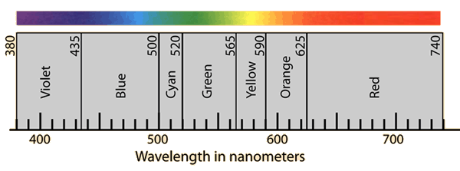](http://www.google.com/url?sa=i&rct=j&q=&esrc=s&source=images&cd=&cad=rja&uact=8&ved=0ahUKEwjn_Nmgr7vMAhXDHB4KHb4NDGUQjRwIBw&url=http://hyperphysics.phy-astr.gsu.edu/hbase/vision/specol.html&bvm=bv.121070826,d.dmo&psig=AFQjCNE_JnxYczUsfUsF-Muga0gXjuZ6NA&ust=1462277712951657)

[](http://www.google.com/url?sa=i&rct=j&q=&esrc=s&source=images&cd=&cad=rja&uact=8&ved=0ahUKEwjn_Nmgr7vMAhXDHB4KHb4NDGUQjRwIBw&url=http://hyperphysics.phy-astr.gsu.edu/hbase/vision/specol.html&bvm=bv.121070826,d.dmo&psig=AFQjCNE_JnxYczUsfUsF-Muga0gXjuZ6NA&ust=1462277712951657)

[](http://www.google.com/url?sa=i&rct=j&q=&esrc=s&source=images&cd=&cad=rja&uact=8&ved=0ahUKEwjn_Nmgr7vMAhXDHB4KHb4NDGUQjRwIBw&url=http://hyperphysics.phy-astr.gsu.edu/hbase/vision/specol.html&bvm=bv.121070826,d.dmo&psig=AFQjCNE_JnxYczUsfUsF-Muga0gXjuZ6NA&ust=1462277712951657)

# A: White light/Sun

# B:________________________

# C:________________________

# D:________________________

# E:________________________

For F, use the chart at the lab station to determine the gas

# F:______________________

# Questions: (H)

1. How are the spectra of the gasses similar? How are they different?
2. Will the spectrum of Hydrogen ever look like the spectrum of helium? Why or why not?
3. Why is spectroscopy (the study of light and spectra) important to learn about space?
4. Quantify your favorite color- Name the color and identify it with a number and units.
5. Nitrogen, a component of Air, has a spectrum very similar to Air? Does that make sense and why?
6. What colors were missing from the Purple or Blue Bulb spectrum? Does that make sense and why?
7. How is the Bug Light Bulb spectrum different from the White bulb?
8. Bug Light Bulbs are more expensive than standard bulbs, is it worth it? Why?
9. There were gaps in the Air Gas Cylinder spectrum. What gas spectrum might fill those gaps? (Hint: The Sun, shining through the atmosphere, gives us a FULL spectrum)

# Questions (A)

1. Will the spectrum of Hydrogen ever look like the spectrum of helium? Why or why not?
2. Why is spectroscopy (the study of light and spectra) important to learn about space?
3. Quantify your favorite color- Name the color and identify it with a number and units.
4. What color has more energy, blue or red?
5. What type of electromagnetic wave has the highest energy?
6. What type of EM wave(s) can humans detect?
7. What has technology allowed us to see?
8. Why might UV rays be harmful while radio waves are safe?